Development of new drug delivery systems based on polymeric
nanofibers for glioblastoma treatment
Pedro V. Badía-Hernández¹, Joan Moll-Carrió¹, María Fuentes-Baile¹, Amalia Mira Carrió¹, Rocío Díaz-Puertas¹, Ma Pilar García-Morales¹, Ricardo Mallavia¹.
¹ Instituto de Investigación, Desarrollo e Innovación en Biotecnología Sanitaria de Elche (IDiBE-UMH), Universidad Miguel Hernández de Elche, Alicante, España.

Abstract:
Glioblastoma is a type of glioma with a low incidence but a high mortality rate due to its malignancy. Current treatments for glioblastoma focus on surgery followed by chemotherapy; however, systemic administration of antineoplastics damages healthy tissues and cells in the rest of the body, so their local application and controlled release is being investigated¹. Their encapsulation in polymeric nanofibers may allow a controlled release and increase their bioavailability^{2,3}. In this work, the electrospinning technique was used to synthesize poly (methyl vinyl ether-alt-maleic) (PMVEMA) nanofibers in both ester (Es) and acid (Ac) forms, as a drug delivery system for carmustine (BCNU) and doxorubicin (DOX). For their morphological characterization, field emission scanning electron microscopy (FESEM) was used, observing diameters between 300 and 400 nm for PMVEMA-Ac nanofibers loaded with DOX at a concentration of 1:20 (% w/w) with respect to the polymer and 737 nm for PMVEMA-Es loaded with BCNU at a concentration of 8:25 (% w/w). In addition, the encapsulation efficiency of the loaded nanofibers was 100 % DOX and 70 % BCNU, confirmed by liquid chromatography (HPLC) with a drug fast release of 1h. On the other hand, the presence of DOX in the nanofibers was observed using the confocal microscopy technique. Finally, the antineoplastic effect of the encapsulated drugs was tested with the MTT cell viability assay in glioblastoma cell lines from patients of the Hospital General Universitario de Elche (HGUE). In this assay, a dose-dependent decrease in cell viability was observed at increasing concentrations of the encapsulated drug. Furthermore, our next step is testing the materials in 3D cell models.

Keywords: PMVEMA; polymeric nanofibers; carmustine; doxorubicin; electrospinning; glioblastoma.
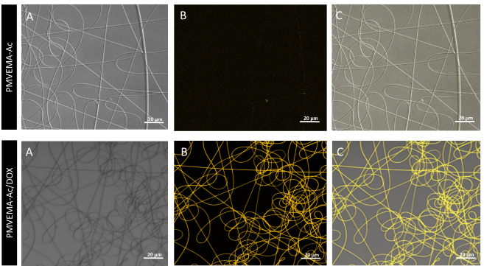
Figure 1: Photographs taken by confocal microscopy of PMVEMA and PMVEMA-Ac/DOX 1% nanofibers. A) Bright field B) Fluorescence C) Merge of A and B. λ_{exc}= 475 nm, λ_{em}= 590 nm.

References:
- Anderson, A. R., & Segura, T. (2020). Injectable biomaterials for treatment of glioblastoma. Advanced materials interfaces, 7(20), 2001055.
- Syed, M. H., Khan, M. M. R., Zahari, M. A. K. M., Beg, M. D. H., & Abdullah, N. (2023). A review on current trends and future prospectives of electrospun biopolymeric nanofibers for biomedical applications. European Polymer Journal, 112352.
- Mira, A., Mateo, C. R., Mallavia, R., & Falco, A. (2017). Poly (methyl vinyl ether-alt-maleic acid) and ethyl monoester as building polymers for drug-loadable electrospun nanofibers. Scientific reports, 7(1), 17205.

